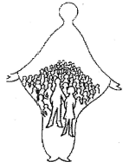
DIOCESE OF SALFORD
ENROLMENT
FOR
RECONCILIATION
AND
FIRST HOLY COMMUNION

